CASE 1: Reference of Parent holding Child. There is Polymorphism.
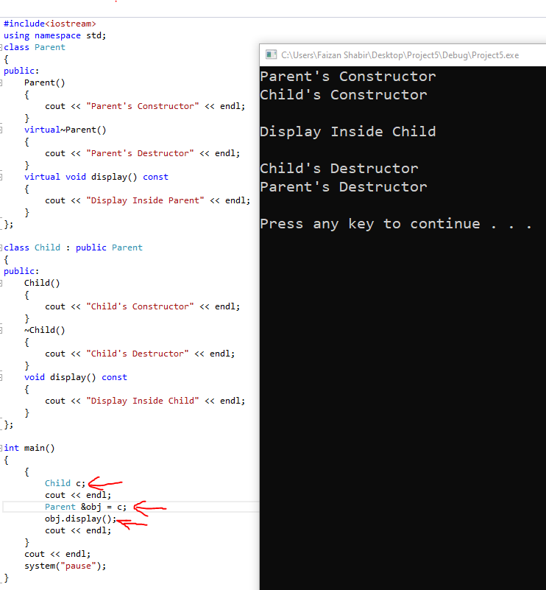

CASE 2: Pointer of Parent holding Child’s Address. There is Polymorphism.
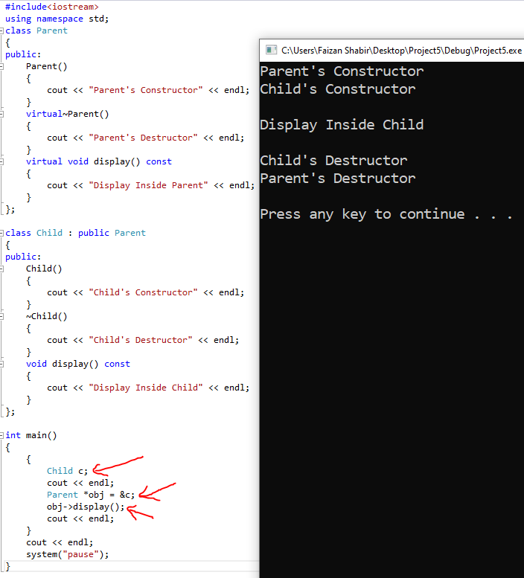

CASE 3: Object of Parent holding Object of Child. There is NO Polymorphism.
